**NCC MERP Meeting**

**June 6, 2023**

**1:30 p.m. – 3:00 p.m.**

**Microsoft Teams**

**_________________________**

**Attendees:**

Matthew Grissinger (ISMP), Chair; Robert Campbell (JC), Vice Chair; Nakia Eldridge (USP), Secretariat; James McSpadden (AARP); Krista Levy (ACCP); Jennie Jarrett (AMA); Holly Carpenter (ANA); Allison Hill (APhA); Avra Thomas (ASCP); Scott Kuzner (AAM); Eileen Lewalski (NABP); Donna Bohannon (USP); Rita Munley Gallagher; Debbie Melnyk

**Observers:** Edward Hagan (ISMP)

**Opening, Procedural, and Administrative Matters**

Mr. Grissinger called the meeting to order at 12:00 p.m. and welcomed everybody to the call. Dr. Eldridge called roll. The summary of the previous meeting was reviewed, approved unanimously with one correction of the last name of Debbie Melnyk.

**Secretariat Report**

There was an 84% response rate for the poll for the three recommendations/statements. The majority vote was an acceptance of the revisions for:

1. *Promoting the Safe Use of Suffixes in Prescription Drug Names*
2. *Recommendation to Enhance Accuracy of Administration of Medications*
3. *Recommendations for Healthcare Organizations to Reduce Medication Errors Associated with the Label*

There have been two updated to the NCC MERP webpage:

1. The subscribing form for NAN Alerts were modified to transition from an iContact document to a Pardot document. This is a format change on the backend of the system to ensure that we capture all submissions in the USP SalesForce collection system.

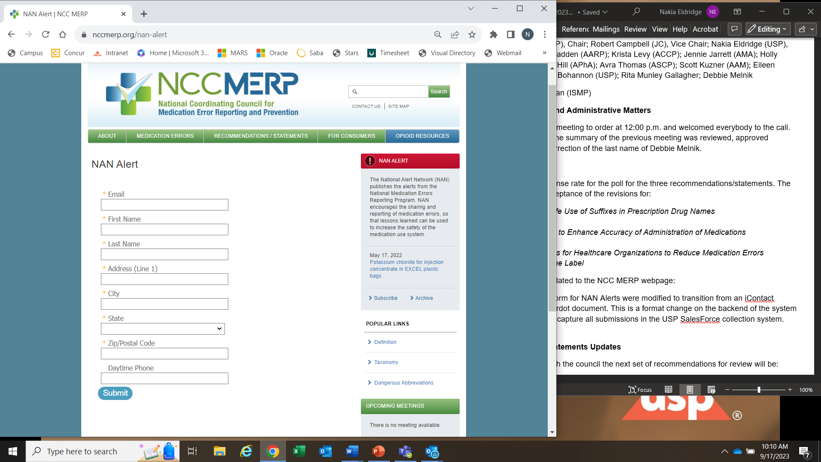

1. We have received a large amount of robot submissions to our Contact Us page. In an effort to minimize this noise and ensure that we receive questions and inquiries from human submissions, we hare replaced the Contact Us form with an e-mail link to submit requests.

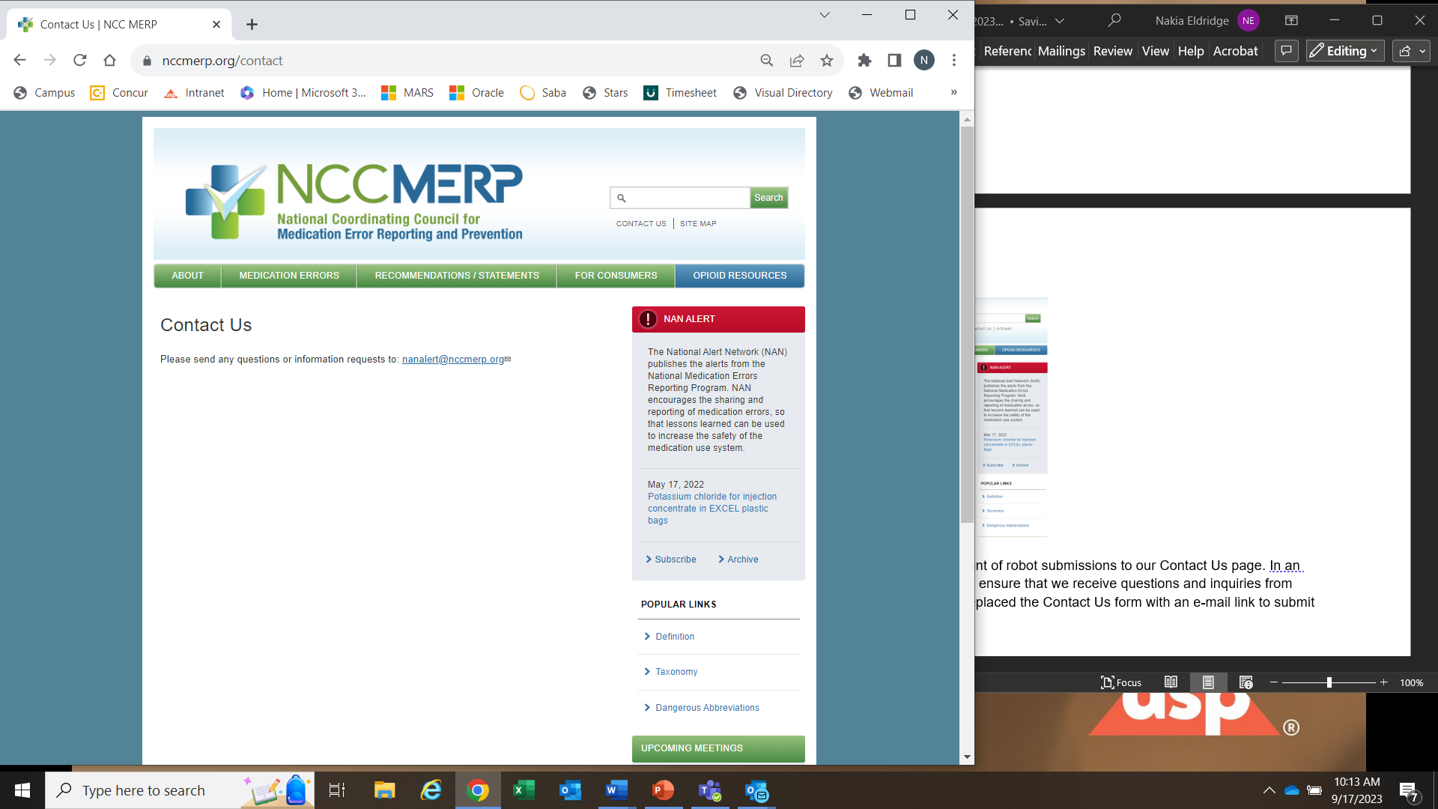

**Recommendations / Statements Updates**

Mr. Grissinger, Mr. Feroli, and ISMP fellow reviewed the following documents and added some additional content for the Council to review:

*1. Statement in Medication Error Rates*

*2. Recommendations to Reduce Medication Errors in Non-Healthcare Settings*

Dr. Eldridge will send the drafted documents out for review, collect responses, and then send for polling by the next quarterly meeting. There are three remaining recommendations/statements that have not been revised in the last five years by the Council. All updated versions are posted on the webpage and will be shared through Linked In.

The Council is open to developing new recommendations and invites all members to make suggestions. Based on the March meeting, there are two new recommendations/statement being developed. The first document, Mr.Grissinger is drafting a statement regarding drug shortages for the Council to review at the next meeting; and the second document will be addressing formulary changes, specifically scenarios where the patient’s medication treatment plan is changed primarily for insurance formulary related reasons (e.g. DOACs).

**Future Topic Discussions**

The Council discussed bringing a speaker to share the current bagging (white, brown, clear, and gold) scenarios and challenges. While most are familiar with white bagging (pharmacy to clinic) and brown bagging (pharmacy to patient to site of administration), there is limited familiarity with newer bagging terms. There were discussions around these models which can or cannot include the pharmacist and in certain cases. NABP shared their 2015-2016 Resolution and paper on this topic. At the next meeting, there can be more discussion around this topic and its implications and impact on patient safety.

Other topics recommended by the Council include:

* COVID emerging virus / vaccine
* Public health emergencies from a medication safety perspective
* Work force burnout
* Speak-up culture
* Patient’s role in medication safety

**Roundtable Sharing**

US Pharmacopeia shared that as of September 1, 2023 the General Chapter <7> Labeling new expiration date format for all manufactured medications that will be requiring a 4-digit year at the beginning of the format: 2026-09 or 2026-SEP and may include the day, when applicable.

ISMP shared their work targeting best practices based on repeated errors including oxytocin errors through standardization and addressing ways to promote potassium chloride safety standards in light of recent Joint Commission changes.

AAM shared their Take 4 Granted campaign including a short video on ways to provide direct relief of medications in the community.

ASCP shared their pilot program with high risk medications and 20+ facilities on prescribing practices.

NABP shared their “SUMMIT” collaboration with APhA and ASHP implementing solutions in the workplace. Their Best Practice document will be available as of July 19th.

The Council did take a moment of silence for Chrissie Blackburn, our patient representative, and offer condolences to her mother. Several patient advocates were recommendation for replacement including Chris Jerry, Donna Horn, and Carol Rhyle. Mr. Grissinger will reach out to them for further consideration. It was also motioned for the webpage to updated.

**Closing**: Meeting adjourned.